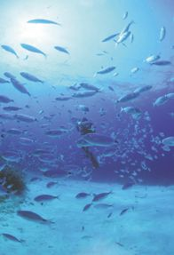
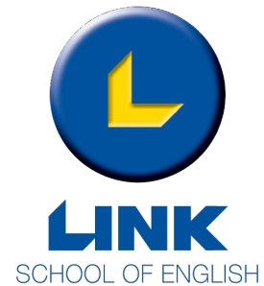
Prices are to be agreed with the schools and with groups.
Programme: General English Course in Group
Course: 20 lessons per week (1 lesson : 45 minutes)
Textbook: One for every student
Accommodation: 3 Star School Hotel Shared Room Half Board
Transfers: Airport / Hotel / Airport
Schoolbus transfers: Included where applicable
Leader: One leader free with every 10 paying (all inclusive – same board basis)
Including: Welcome drink, orientation walk, information pack, LINK wallet & pencil, student card offering numerous discounts, assessment test on arrival, tutorial session and Certificate on completion of course
Excursions: Prices are to be agreed with the schools and with groups (all transport included).

 | Morning | Afternoon | Evening
Monday | Lessons | Orientation Walk | Water Colour Competition
Tuesday | Lessons | Tutorial Session | Film Night
Wednesday | Lessons | Valletta Guided Tour | Disco Night
Thursday | Lessons | Treasure Hunt | Games with Leaders
Friday | Lessons | Tutorial Session | Bowling Night
Saturday | Harbour Cruise |  | Music in Hotel
Sunday | Departure to Airport
This program can be agreed.

Tailor-made packages and Winter Rates are also available upon request.
Terms and conditions apply.
Company Registration Number : C14840 - Link School of Languages Ltd.

TALK TO ME !!!!
UN CORSO PER FARTI
PARLARE !!!!

Link School English,
88/90, Triq it-Tiben, Swieqi, SWQ3034 Malta
Tel: (+356) 2138 2634, 2138 2642,
2138 4825, 2137 3530
E-Mail: sunlinguamalta@libero.it
Skype : linkschoolmalta
www.linkenglishschool.com

